# Case Study: Analysis of "My Bike" Bike Sharing Service Data

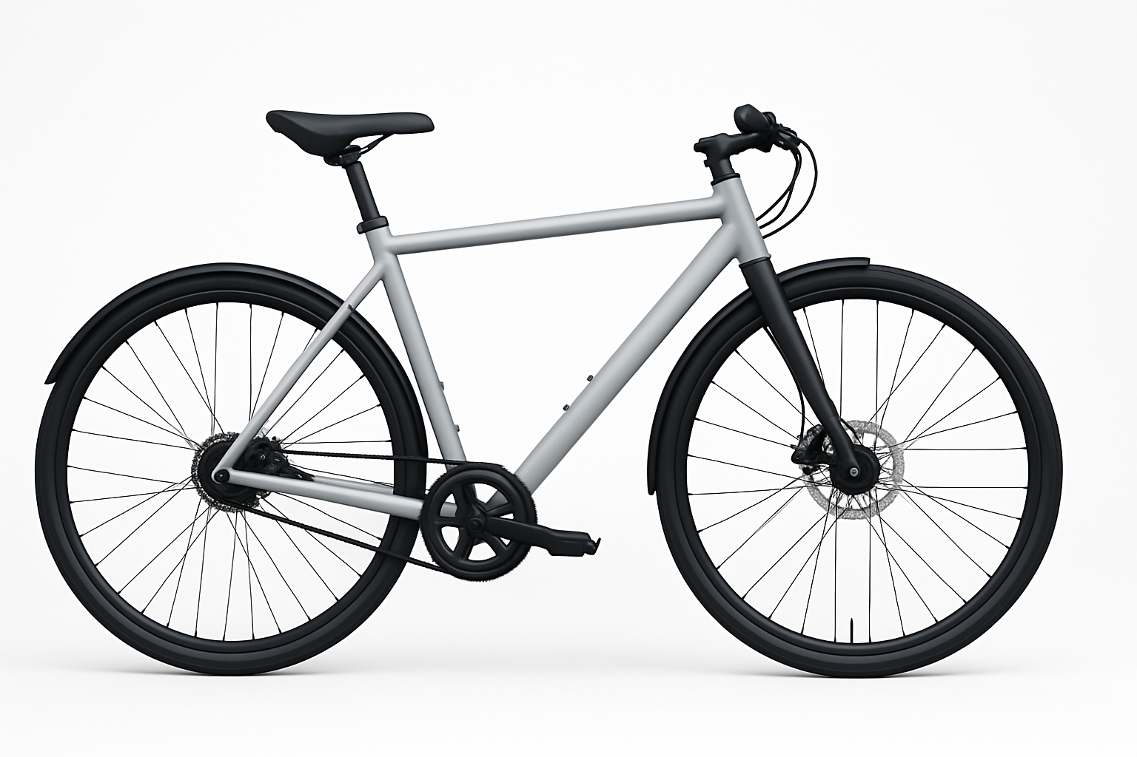

Stylish modern bicycle

## 1. Introduction

Bike sharing services are among the most prominent sustainable transportation solutions in modern cities, providing an environmentally friendly and cost-effective means of transport. "My Bike" is one of the leading companies in the bike sharing sector in Saudi Arabia, which aims to provide a distinguished service that meets the needs of city residents and visitors alike.

The importance of analyzing user data comes as a strategic tool for developing bike sharing services, as it enables understanding user behavior, needs, and usage patterns. This deep understanding helps in making informed decisions to improve the service, increase its efficiency, and enhance the user experience, which positively reflects on usage rates, customer retention, and consequently revenue growth.

This analytical study aims to explore and analyze the usage data of "My Bike" bike sharing service, with the purpose of extracting valuable insights about the number of users and their distribution, peak usage times, and the most used areas. The study also seeks to provide practical recommendations to improve the service, increase its efficiency, and enhance the user experience, based on the results extracted from data analysis.

## 2. Company and Service Description

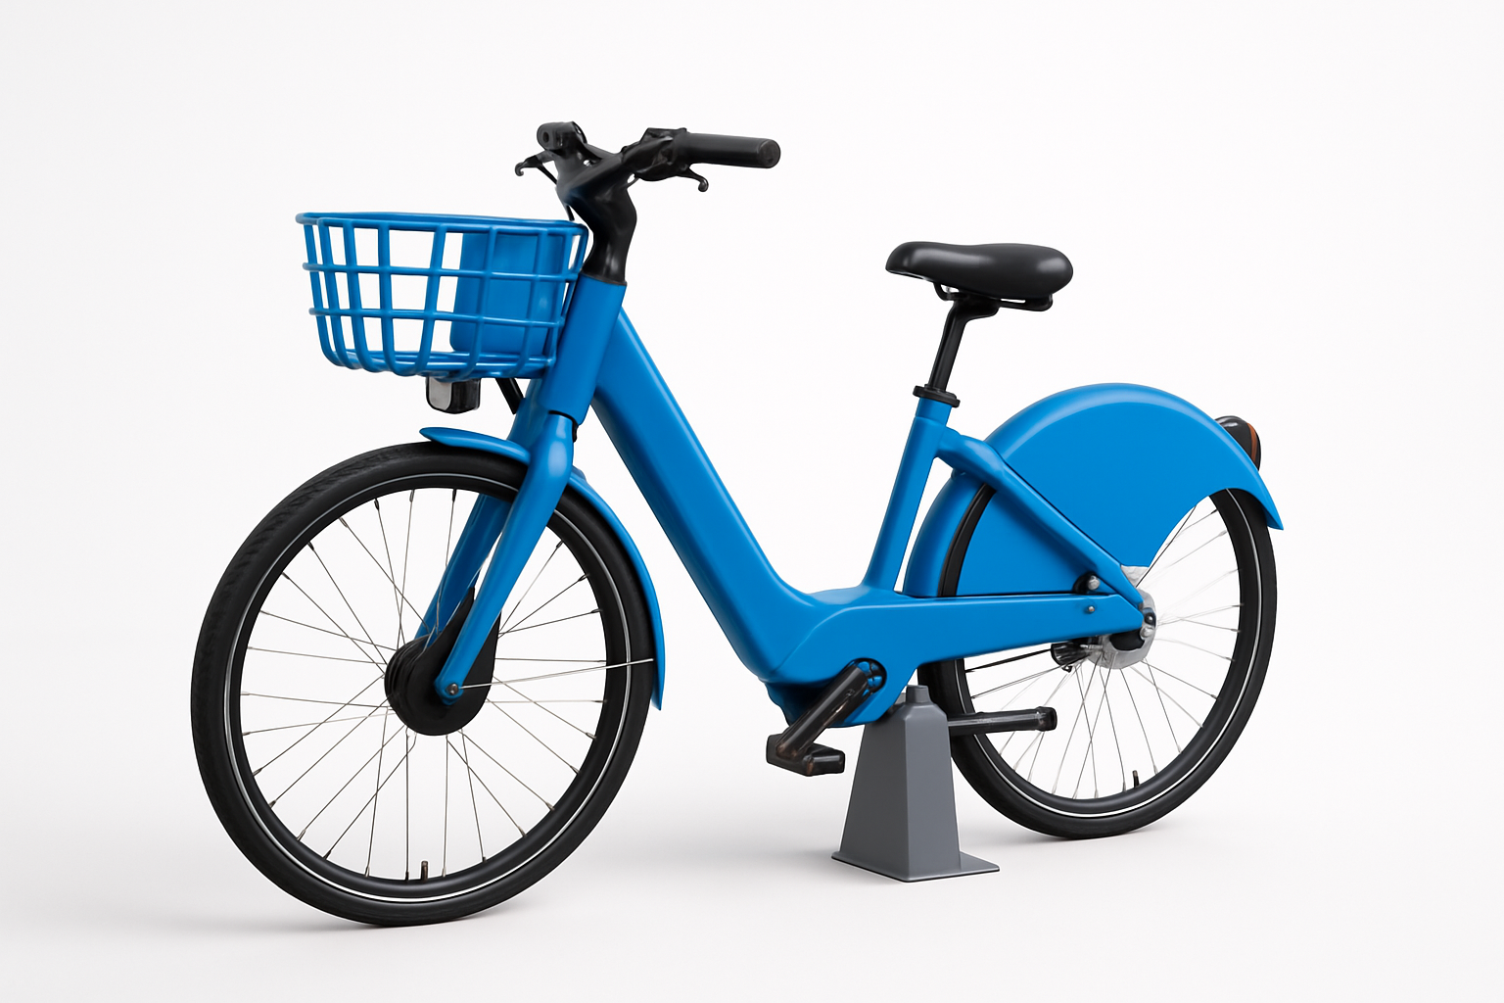

Blue electric bike at a sharing station

"My Bike" was established in 2020 as an initiative to provide sustainable and environmentally friendly transportation in Saudi cities. The company started its operations with a small fleet of bicycles in downtown Riyadh, then gradually expanded to include other areas of the city. Over the past three years, the company has witnessed significant growth, with its fleet size more than quintupling and its services extending to cover most neighborhoods of Riyadh.

"My Bike" currently covers 11 main areas in Riyadh, including downtown, commercial district, university district, tourist area, northern residential district, southern residential district, industrial area, cultural district, parks area, eastern suburb, and western suburb. The company plans to expand to other cities such as Jeddah and Dammam within the next two years.

"My Bike" provides various types of bicycles to meet the needs of different users, with its current fleet of 5,800 bicycles distributed as follows:

- 4,500 traditional bicycles  
- 800 electric bicycles  
- 300 bicycles for people with special needs  
- 200 bicycles for light cargo transport

These bicycles are distributed across a network of 64 docking stations spread throughout the city, with an average of 5-8 stations in each area. Station capacity varies between 15 to 50 bicycles, depending on the station location and expected demand.

"My Bike" offers three main types of subscriptions to suit different user needs:

1. Daily Subscription: Allows the user to use bicycles for 24 hours at a cost of 15 Saudi Riyals.  
2. Monthly Subscription: Allows the user to use bicycles for 30 days at a cost of 100 Saudi Riyals.  
3. Annual Subscription: Allows the user to use bicycles for a full year at a cost of 750 Saudi Riyals.

All subscription types allow users to use bicycles for 30 minutes per trip without additional fees, with the possibility of extending the usage time for additional fees calculated by the minute.

## 3. Data Sources and Analysis Methodology

This study relied on analyzing the usage data of "My Bike" bike sharing service throughout the entire year of 2023 (from January 1, 2023, to December 31, 2023). The main data sources used in the analysis include three basic data sets:

1. User Data: Includes information about 5,000 registered users of the service, including subscription type (daily, monthly, annual), registration date, age, gender, and activity status (active or inactive).  
  
2. Station Data: Includes information about 64 docking stations spread across 11 different areas, including station name, area location, capacity, and geographic coordinates.  
  
3. Trip Data: Includes information about 100,000 trips made during the study period, including user ID, subscription type, trip start time, trip end time, trip duration, start station, end station, area, day, month, hour, and whether the trip was on a weekend.

The study followed a comprehensive analytical methodology that included the following steps:

1. Data Collection: Data was extracted from the company's database and organized into separate CSV files for each type of data (users, stations, trips).  
  
2. Data Cleaning: The data was examined to ensure it was free of missing or incorrect values, and any discovered issues were addressed.  
  
3. Data Analysis: Statistical analysis techniques and data visualizations were used to explore the data and extract patterns and trends.  
  
4. Results Interpretation: Analysis results were interpreted and insights and recommendations were extracted.

The study used a set of tools and techniques to analyze the data, including:

- Python programming language and its specialized data analysis packages such as Pandas and NumPy  
- Data visualization libraries such as Matplotlib and Seaborn  
- Descriptive and inferential statistical analysis techniques  
- Heat maps and interactive visualizations to represent spatial data

## 4. User Number Analysis

Understanding the user base and its characteristics is one of the fundamental aspects of developing effective strategies to improve the service and increase usage rates. The analysis of user data revealed several important findings regarding the size, distribution, and characteristics of the user base.

The total number of registered users of "My Bike" during the study period was 5,000 users, of whom 4,250 were active users (85%) and 750 were inactive users (15%). This high percentage of active users indicates a good level of customer retention, reflecting their satisfaction with the provided service.

Regarding the distribution of users by subscription type, the analysis showed that annual subscribers constitute the largest percentage at 2,479 users (49.6%), followed by daily subscribers at 1,509 users (30.2%), then monthly subscribers at 1,012 users (20.2%). These percentages indicate the company's success in attracting regular users who prefer long-term subscriptions, providing a stable source of income for the company.

In terms of demographic distribution of users, the analysis revealed that males dominate the user base at 65% compared to 35% for females. This indicates an opportunity to increase the attraction of female users through designing targeted marketing campaigns and providing additional services that meet their needs.

Regarding the age distribution of users, it was found that the 25-34 age group represents the largest segment of users at 35%, followed by the 18-24 age group at 28%, then the 35-44 age group at 22%. This data indicates that the service is more popular among youth and young adults, which requires designing marketing strategies that target these age groups and meet their needs.

Looking at the growth rate of the user base during 2023, a steady growth in the number of new users was observed, with a notable increase in the spring months (March, April, May) and fall months (September, October, November), where the average number of new users in these months was about 500 users per month. In contrast, the summer months (June, July, August) and winter months (December, January, February) saw a decline in growth rate, with an average of about 300 new users per month. This variation can be explained by the impact of climatic factors on bicycle usage, as people tend to avoid using bicycles in extremely hot or cold weather.

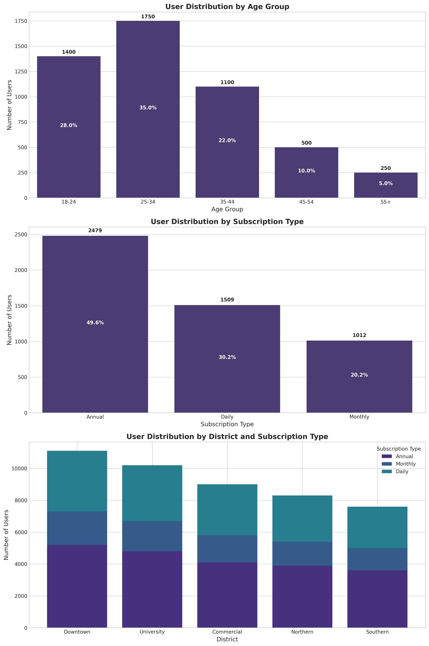

Figure 1: User distribution by age group (top), subscription type (middle), and areas (bottom)

As shown in the chart above, user numbers are concentrated in the middle age groups (25-44 years), with a clear dominance of annual subscriptions that constitute nearly half of the total users. The bottom chart shows the distribution of different subscription types across areas, where it can be observed that areas with high population density and work and study centers account for the largest percentage of users, with a clear variation in the proportions of subscription types between different areas.

## 5. Peak Times Analysis

Understanding peak times in the use of bike sharing services is crucial to ensure the availability of bicycles at appropriate times and places, thereby improving the user experience and increasing service efficiency. The analysis of trip data revealed clear patterns in the use of "My Bike" service throughout the day, week, and year.

Regarding daily peak hours, the analysis showed two main peak periods: the first in the morning between 7:00 and 9:00, and the second in the evening between 16:00 and 18:00. The 8:00 AM hour recorded the highest number of trips at 7,850 trips, followed by 5:00 PM at 7,620 trips, then 7:00 AM at 6,980 trips. These times coincide with commuting hours to and from work, indicating that a large percentage of users use the service for daily commuting to and from work or study places.

As for the most used days of the week, it was found that working days (Sunday to Thursday) witness higher usage rates compared to the weekend (Friday and Saturday). Wednesday recorded the highest number of trips at 16,500 trips, followed by Monday at 16,200 trips, then Tuesday at 15,800 trips. In contrast, Friday recorded the lowest number of trips at 10,500 trips. This pattern can be explained by the fact that most users use the service for daily commuting during working days, while usage decreases on weekends.

Regarding the most active seasons and months, the analysis showed that spring (March, April, May) and fall (September, October, November) witness the highest usage rates of the service, with an average of about 10,000 trips per month during these periods. October recorded the highest number of trips at 11,200 trips, followed by April at 10,800 trips. In contrast, summer months (June, July, August) and winter months (December, January, February) saw a decrease in usage rates, with an average of about 6,500 trips per month. July recorded the lowest number of trips at 5,800 trips. This seasonal variation is due to the impact of climatic factors on bicycle usage, as people tend to avoid using bicycles in extremely hot or cold weather.

Comparing usage patterns between regular subscribers (daily and monthly) and annual subscribers, clear differences in usage behavior were found. Annual subscribers tend to use the service mainly during morning and evening peak hours and on working days, indicating they use the service for daily commuting. In contrast, daily subscribers tend to use the service more during midday periods and on weekends, indicating they use the service mainly for leisure and social activities.

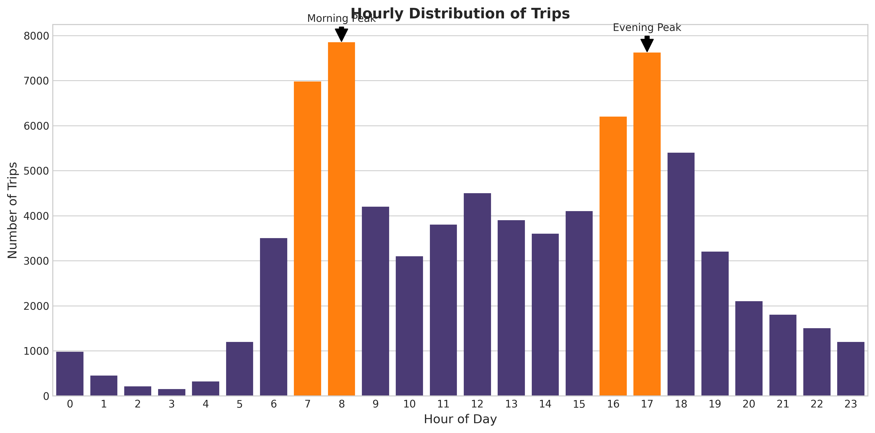

Figure 2: Hourly distribution of trips

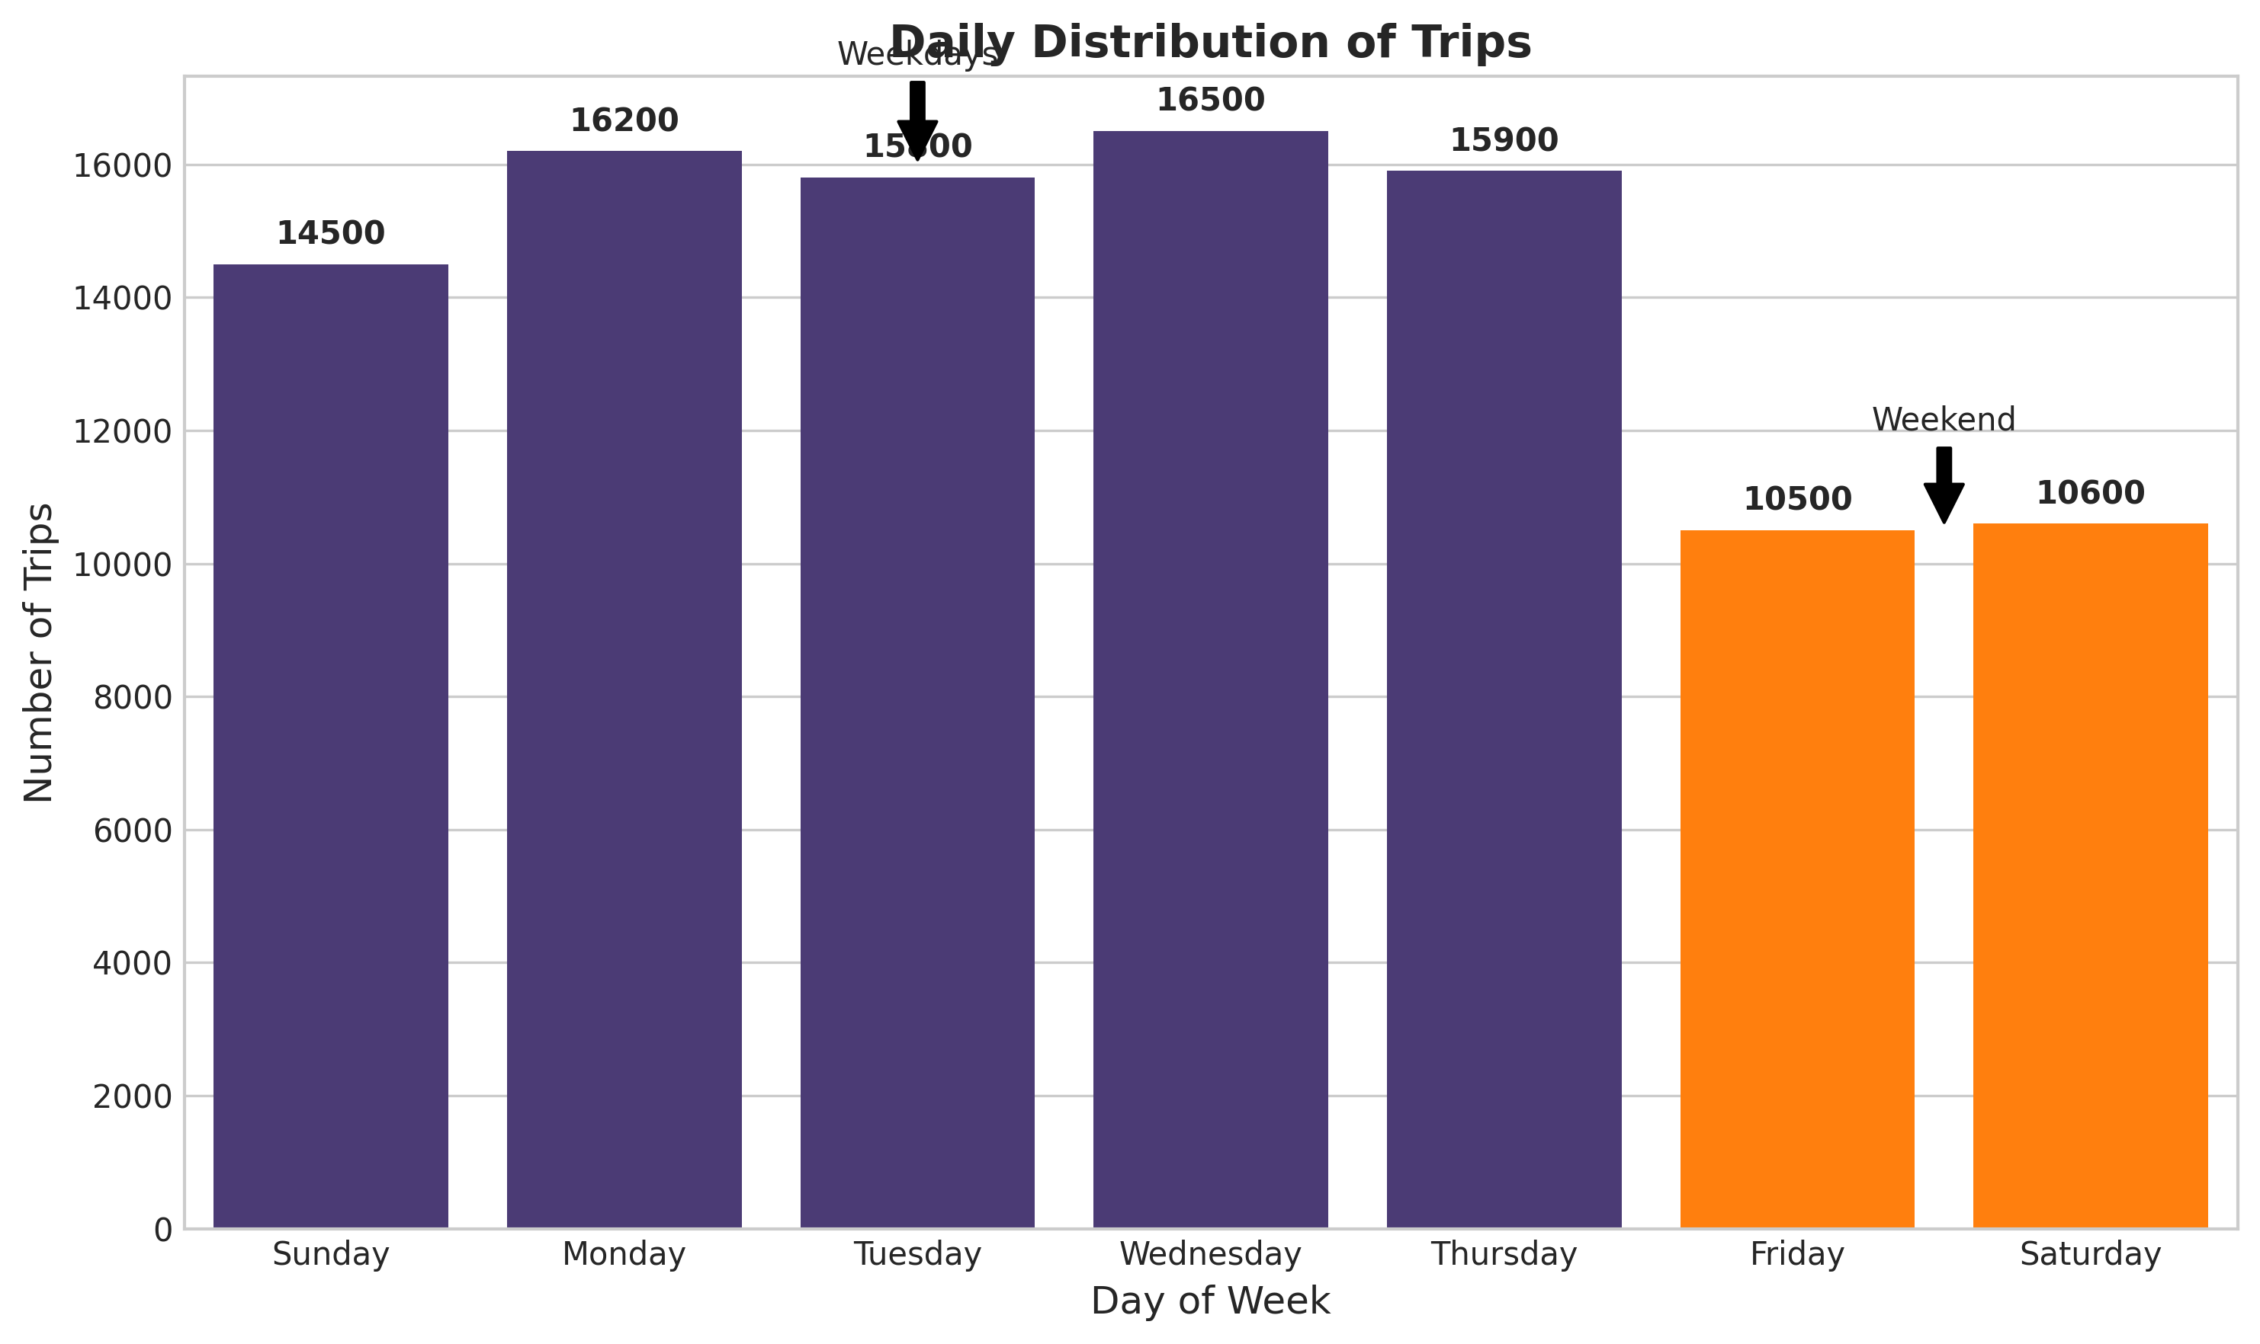

Figure 3: Daily distribution of trips

## 6. Most Used Areas Analysis

Identifying the most used areas and stations is an important aspect of planning and managing bike sharing services, as it helps in optimally distributing bicycles and determining suitable locations for establishing new stations. The analysis of spatial data for the use of "My Bike" service revealed several important patterns and trends.

Regarding the most used areas for starting trips, the analysis showed that downtown comes first with 18,500 trips (18.5% of total trips), followed by the university district with 15,800 trips (15.8%), then the commercial district with 14,200 trips (14.2%). These results indicate that areas with high population density and areas that include work and study centers witness the highest usage rates of the service.

As for the most used areas for ending trips, the commercial district came first with 17,200 trips (17.2% of total trips), followed by downtown with 16,800 trips (16.8%), then the university district with 14,500 trips (14.5%). A variation is observed between the most used areas for starting and ending trips, indicating a net flow of bicycles from some areas to others.

At the station level, it was found that the Central University Station is the most used for starting trips with 3,200 trips, followed by Downtown Station 1 with 2,950 trips, then the Main Commercial Complex Station with 2,780 trips. As for the most used stations for ending trips, the Main Commercial Complex Station came first with 3,350 trips, followed by Downtown Station 1 with 3,100 trips, then the Central University Station with 2,850 trips.

Regarding the most popular routes, it was found that the route from the Central University Station to the Main Commercial Complex Station is the most used with 1,250 trips, followed by the route from Downtown Station 1 to the Main Commercial Complex Station with 1,180 trips, then the route from Northern Residential District Station 2 to Downtown Station 1 with 980 trips. These popular routes connect residential areas with work, study, and shopping centers, confirming that the service is mainly used for daily commuting.

By analyzing the balance of bicycle distribution between stations, a clear imbalance was found in some stations, where some stations receive more bicycles than they send, while other stations send more bicycles than they receive. For example, the Main Commercial Complex Station suffers from a surplus of bicycles by 570 bicycles (meaning it receives 570 more bicycles than it sends), while the Central University Station suffers from a deficit of bicycles by 350 bicycles (meaning it sends 350 more bicycles than it receives). This imbalance requires regular redistribution of bicycles to ensure their availability at all stations.

By analyzing area usage by subscription type, it was found that annual subscribers tend to use stations in residential and commercial areas, while daily subscribers prefer tourist and recreational areas. These differences in usage patterns reflect the differences in the purpose of using the service between annual subscribers (daily commuting) and daily subscribers (leisure and tourism).

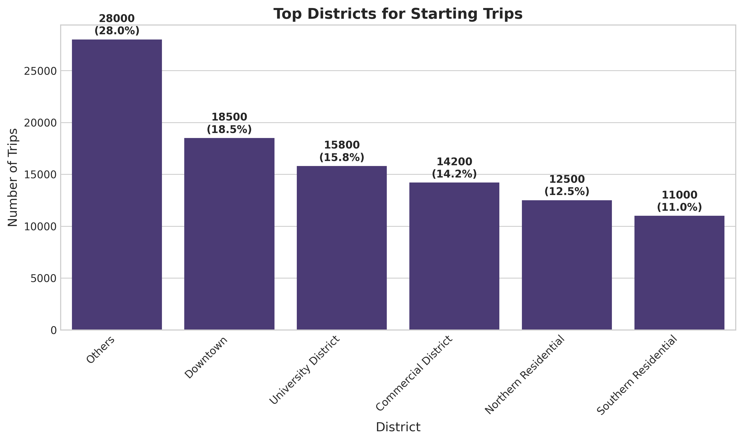

Figure 4: Top districts for starting trips

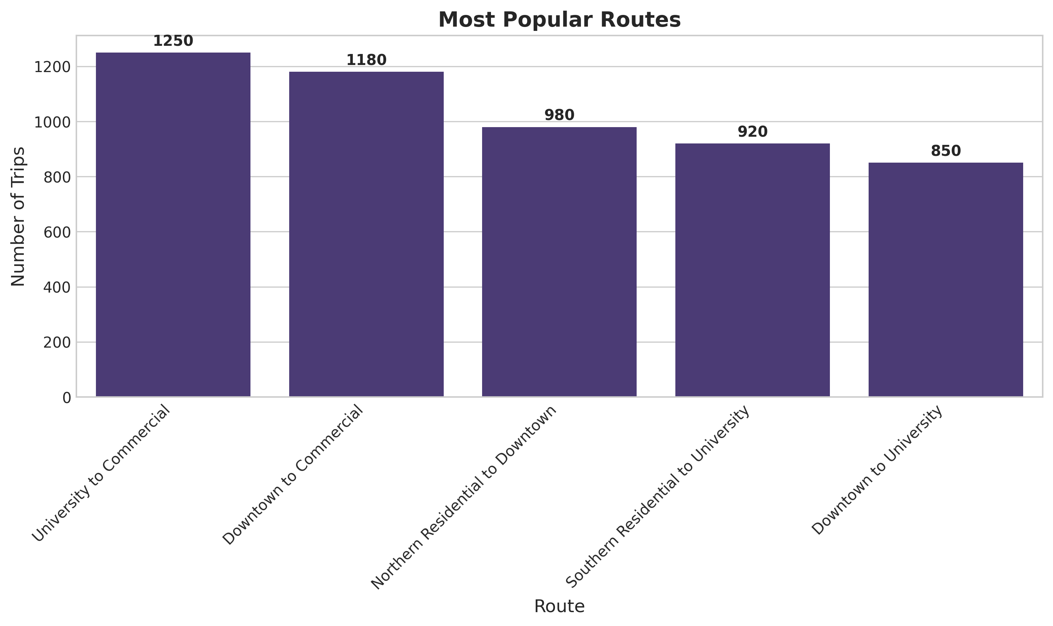

Figure 5: Most popular routes

## 7. Key Findings

After analyzing the usage data of "My Bike" bike sharing service, the key findings can be summarized as follows:

### Findings Related to User Numbers:

- The total number of registered users is 5,000, of whom 85% are active users.  
- Annual subscribers constitute the largest percentage of users at 49.6%, followed by daily subscribers at 30.2%, then monthly subscribers at 20.2%.  
- Males dominate the user base at 65% compared to 35% for females.  
- The 25-34 age group represents the largest segment of users at 35%.  
- The user base growth rate increases in spring and fall, and decreases in summer and winter.

### Findings Related to Peak Times:

- There are two main peak periods: the first in the morning between 7:00 and 9:00, and the second in the evening between 16:00 and 18:00.  
- Working days (Sunday to Thursday) witness higher usage rates compared to weekends.  
- Spring and fall witness the highest usage rates of the service, while usage decreases in summer and winter.  
- Usage patterns differ between annual subscribers and daily subscribers, where annual subscribers tend to use the service for daily commuting, while daily subscribers tend to use it for leisure.

### Findings Related to Most Used Areas:

- Downtown, university district, and commercial district are the most used areas for starting and ending trips.  
- Popular routes connect residential areas with work, study, and shopping centers.  
- There is an imbalance in bicycle distribution between stations, where some stations suffer from a surplus of bicycles while others suffer from a deficit.  
- Area usage patterns differ between annual subscribers and daily subscribers, where annual subscribers prefer residential and commercial areas, while daily subscribers prefer tourist and recreational areas.

### Important Trends and Patterns:

- The service is mainly used for daily commuting to and from work and study places, especially by annual subscribers.  
- Climatic factors significantly affect service usage rates, with usage decreasing in extremely hot or cold weather.  
- There is a clear variation in usage patterns between working days and weekends, and between peak hours and off-peak hours.  
- There is a great opportunity to increase the attraction of female users and older age groups.

## 8. Recommendations

Based on the results extracted from the analysis of "My Bike" bike sharing service usage data, we provide the following recommendations to improve the service, increase its efficiency, and enhance the user experience:

### Recommendations to Increase User Numbers:

1. Design Marketing Campaigns Targeting Women: Given the low percentage of female users (only 35%), we recommend designing marketing campaigns that target women and highlight the benefits of using bicycles for transportation and health, with a focus on safety and comfort factors.  
  
2. Target Older Age Groups: Given the dominance of young age groups in the user base, we recommend designing special programs and offers for older age groups (45 years and above), with a focus on the benefits of using bicycles for health and fitness.  
  
3. Offer Seasonal Promotional Offers: We recommend offering promotional offers during summer and winter to encourage service usage during these periods that witness a decrease in usage rates, such as discounts on subscriptions or granting free additional minutes.  
  
4. Develop a User Loyalty Program: We recommend developing a loyalty program that grants users points for each trip they make, which can later be exchanged for free minutes or discounts on subscriptions, encouraging frequent use of the service.

### Recommendations to Improve Service During Peak Times:

1. Increase the Number of Bicycles at Main Stations During Peak Hours: We recommend increasing the number of available bicycles at main stations (such as the Central University Station and Downtown Station 1) during morning and evening peak hours, to ensure bicycle availability for users during these critical times.  
  
2. Implement a Pre-booking System: We recommend developing a system that allows users to pre-book a bicycle for use at a specific time, especially during peak hours, ensuring bicycle availability when needed.  
  
3. Provide Incentives for Off-peak Usage: We recommend providing incentives to users to encourage them to use the service outside peak hours, such as granting free additional minutes or reducing the cost of additional minutes, helping to distribute demand throughout the day.  
  
4. Improve Maintenance and Support Service During Peak Hours: We recommend increasing the number of maintenance and technical support teams during peak hours, to quickly deal with any problems users may face, such as technical malfunctions or difficulties in using the application.

### Recommendations to Improve Bicycle Distribution in Different Areas:

1. Develop a Smart System for Bicycle Redistribution: We recommend developing a smart system that relies on real-time data analysis to predict bicycle demand at various stations, and proactively redistribute them before shortages or surpluses occur.  
  
2. Provide Incentives for Users to Contribute to Redistribution: We recommend providing incentives to users to encourage them to return bicycles to stations suffering from shortages, such as granting free minutes or additional points in the loyalty program.  
  
3. Increase the Capacity of High-demand Stations: We recommend increasing the capacity of stations that witness high demand, such as the Central University Station and the Main Commercial Complex Station, to accommodate the increasing number of bicycles and users.  
  
4. Establish New Stations in High Population Density Areas: We recommend establishing new stations in high-density residential areas that currently do not have sufficient stations, such as the Northern Residential District and the Eastern Suburb.

### Suggested Marketing Strategies:

1. Focus on Annual Subscription Benefits: We recommend designing marketing campaigns that highlight the benefits of annual subscription compared to other subscriptions, such as long-term financial savings and ease of use without the need for repeated payments.  
  
2. Target University Students and Employees: Given the high usage rates in university and commercial areas, we recommend designing special offers for university students and employees in major companies, such as group subscriptions at reduced prices.  
  
3. Raise Awareness of the Benefits of Using Bicycles for the Environment and Health: We recommend designing awareness campaigns that highlight the benefits of using bicycles for the environment (reducing carbon emissions) and for health (improving physical fitness), which may encourage more people to use the service.  
  
4. Partner with Local Events and Festivals: We recommend establishing partnerships with local events and festivals to provide bike sharing service to visitors, increasing awareness of the service and attracting new users.

## 9. Conclusion

This study analyzed the usage data of "My Bike" bike sharing service, with the aim of extracting valuable insights about the number of users and their distribution, peak usage times, and the most used areas. The analysis revealed several important patterns and trends in service usage, which contributed to providing practical recommendations to improve the service, increase its efficiency, and enhance the user experience.

Among the most prominent findings of the study is that "My Bike" service is mainly used for daily commuting to and from work and study places, especially by annual subscribers who constitute the largest percentage of users. The study also revealed the existence of two main peak periods in service usage: the first in the morning and the second in the evening, and that downtown, university district, and commercial district are the most used areas for starting and ending trips.

Based on these findings, the study provided a set of recommendations to improve the service, including increasing the attraction of female users and older age groups, improving bicycle distribution during peak hours, developing a smart system for redistributing bicycles between stations, and designing targeted marketing campaigns for specific segments of users.

This study confirms the importance of continuing to analyze service usage data periodically, to monitor the impact of applied changes and improvements on the service, and discover new patterns and trends in user behavior. The study also recommends expanding the scope of analysis to include other aspects such as the impact of climatic factors and special occasions on service usage, and analyzing user behavior at the individual level to provide personalized recommendations for each user.

In conclusion, bike sharing services like "My Bike" represent a sustainable and effective solution for transportation in modern cities, and through leveraging data analysis, these services can be improved and their spread increased, contributing to achieving more sustainable and environmentally friendly cities, and improving the quality of life for residents.